Cocktailkarte

Ipanema € 2,50
(Limette, Rohrzucker, Limettensaft, Ginger Ale)

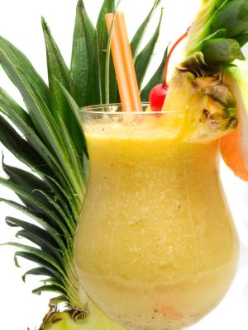

Virgin Colada € 2,50
(Ananassaft, Coconutsirup, Sahne)


Florida € 2,50
(Orangensaft, Ananassaft, Zitronensaft, Grenadinesirup)

