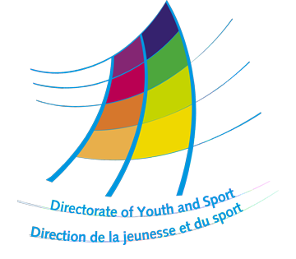

www.coe.int/youth

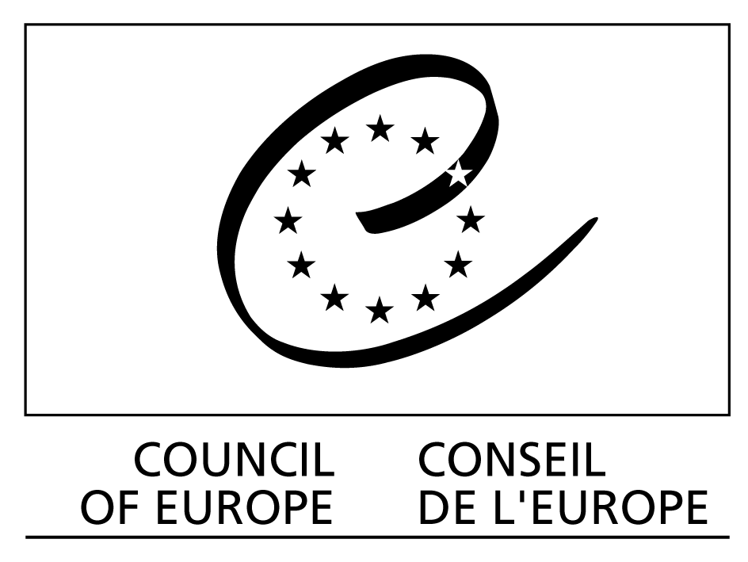

Strasbourg, 15 April 2009

“Intercultural Dialogue
in Youth Work”

Training courses
with Arabic, Russian or Turkish language option
for the partners of the Youth Sector

Training courses with English language option
for local Arab, Russian and Turkish NGOs

Call for applications

Directorate of Youth and Sport
AGORA
Council of Europe
F – 67075 STRASBOURG CEDEX
Tel: +33 (0)3 88 41 23 00
Fax: +33 (0)3 88 41 27 78
E-mail: youth.language@coe.int

1. Introduction

Intercultural competence and foreign language skills are seen as essential preconditions for youth mobility, for the development of international activities and for increased youth participation, one of the key priorities of the Council of Europe’s Directorate of Youth and Sport. The present programme consisting of three separate courses puts the improvement of foreign language skills at the service of youth work and intercultural communication through a non formal education methodology.

The aim of the programme is to promote intercultural and interreligious dialogue with a special focus on youth work at European level by bringing together young people from different backgrounds and countries. This approach aims at contributing to an active, critical understanding of one’s own culture and of other people’s culture. The programme also encourages an interest in areas other than just language: history, politics, culture, geography, religion and everyday life in the host country. The strategic objectives of this programme are to:

- promote intercultural dialogue and co-operation;
- provide young people and youth workers with the opportunity to discover the diversity of youth actions in different countries;
- encourage networking and creation of projects among them.

This year’s programme brings together participants not only from various European countries but also from the host country itself, thus allowing for a day-to-day direct networking between the local partners and those from other European countries. While international participants will improve their proficiency of the language of the host country (Arabic or Russian or Turkish), the participants from local/national partners (from Russia, Turkey, Morocco) will improve their English language skills. Thus the morning language sessions will be held separately, whereas the youth work workshops and cultural programme in the afternoons and evenings will be a joint activity.

All candidates and partners must use the application and endorsement forms shown as Appendices I and II.

2. Practical information

Where and when

Each course takes place during three weeks in the country in which the language is spoken.

Arabic: Rabat, Morocco, from 19 July to 6 August 2009. Arrival date is 18 July and departure date is 7 August 2009.

Russian: Moscow, Russia, from 22 June to 11 July 2009. Arrival date is 21 June and departure date is 12 July 2009.

Turkish: Istanbul (2 weeks) and Trabzon (1 week), Turkey, from 13 July to 1 August 2009. Arrival date is 12 July and departure 2 August.

The Council of Europe and partner institutions will cover the cost of tuition, accommodation and meals of the participants. Participants must be aware that they will have to cover these costs themselves if they are absent from any part of the course without good reason, approved in advance by the course education team. Travel expenses and visa fees (for those who need a visa) should be covered by the participants themselves or the supporting organisation.

No pocket money for other activities will be provided. Participants should find out about local price levels and make sure they have enough pocket money for their own personal expenses and extra-curricular activities.

Important: The participants must attend the whole course without missing any days. Commitment, initiative and active participation will be expected. Those who already participated in the Directorate of Youth and Sport Intercultural Language Programme in previous years are NOT eligible to re-apply.

3. The course contents

3.1 Objectives

The learning objectives are to develop the knowledge and experience of participants:

- on intercultural learning and intercultural dialogue:
  - raising awareness on the importance of intercultural learning for intercultural dialogue;
  - encouraging intercultural dialogue through language learning and networking with local NGOs, youth associations and other partners in the host country ;
  - creating a link between participants’ experiences during the course and their youth work reality.

- on youth work:
  - gaining knowledge about the youth organisations represented by the participants and youth work in the host country;
  - getting to know European structures for youth work;
  - reflecting about the role of youth work.
3.2 Methods

The course combines various elements that provide participants with an understanding of interculturality and communication skills in the target language(s):

- workshops and activities on intercultural learning, interreligious dialogue and international youth work in the target language;
- classroom sessions using a variety of materials and activities relevant to youth work and the participants’ needs and interests and linked to topical workshops; these sessions provide opportunities for practising the skills of listening, speaking, reading and writing as well as for developing a knowledge of grammar and vocabulary;
- periods of individual study for practising specific skills and consolidating learning;
- a programme of cultural and youth work visits.

3.3 Educational team

The educational teams comprise language teachers and two youth work trainers fluent in the language of the host country and in English. They alternate their sessions but coordinate them to ensure that language learning and non-linguistic learning are linked and are mutually enriching, and that similar methodologies (non-formal approaches and practices) are used. However, the success of the course depends on the participants’ own initiative and the responsibility they take for their learning.

4. Application

4.1 Who can participate?

Applicants must:

- be active in a youth organisation/structure connected to one of the following youth organisations/structures: (ONLY the organisations/structures mentioned below are able to support applications.)

- an international non-governmental youth organisation or network;
- a national, regional or local non-governmental youth organisation or network;
- a national youth council;
- a national agency of the YOUTH Programme of the European Union;
- a municipality, a local, regional or national authority;
- a ministry or the CDEJ (European Steering Committee for Youth).

- be able to conduct a simple conversation in, or be a middle-level speaker of, the host country’s language (complete beginners will be completely lost during the course; too advanced learners will get bored. Please be honest with yourself and with the course organisers about your level of language skills);
- have a satisfactory level of English, since part of the training will be conducted in English;
- be aged between 18 – 30 years;
- have an interest in the intercultural dimension of the course;
- have a clearly defined need for developing intercultural language competences;
- be committed to taking on responsibilities at international level in his/her organisation;
- be willing to contribute to the development of the programme and to the group processes, and to take responsibility for their own learning;
- be resident of a member state of the Council of Europe (in the case of the Arabic course: be a resident of a member state of the Council of Europe or of ISESCO).

This programme should be seen as an opportunity for capacity-building for youth organisations and youth partners. For this reason, candidates must be nominated by their organisation. The organisation must justify its choice through the benefit which the candidate represents for the projects or activities implemented within the organisation, or for the organisation’s development at European/international level.

Quantitative aspects for a balance within the group will be taken into account, in particular:

    - maximum quota per type of organisation;
    - gender balance;
    - geographical balance.

4.2 Application procedure

The applicant should return the completed application form to his or her nominating organisation before the date mentioned in the respective calendar (see below). The nominating organisation will then select their preferred candidate; if there are two or more candidates, they should be listed by order of priority. No individual applications will be accepted.

The nominating organisation must forward the scanned version of the signed application, along with a signed recommendation letter for each applicant, to the Secretariat by e-mail to the following address: youth.language@coe.int. The deadline for the respective course indicated in the table below must be respected (deadline is midnight Central European Summer Time).

All applicants and their supporting organisation will be notified of the selection results by email.

- No applications will be accepted after the deadline.
- Incomplete applications will not be accepted.
- Applications without recommendation letters are not eligible.
- Applications not presented by one of the above mentioned organisations/structures are not eligible.

5. Calendar 2009 for the selection of participants:

Arabic:

15 April | Publication of the call for applications
20 May | The applicant should return his/her application to his/her nominating organisation.
3 June | Council of Europe deadline for applications (all applications must be accompanied by a recommendation letter)
12 June | Council of Europe informs the applicants on their status (acceptance or waiting list)
19 June | Accepted applicants must confirm their participation to the Council of Europe
19 July to 6 August | Training course dates

Russian

15 April | Publication of the call for applications
13 May | The applicant should return his/her application to his/her nominating organisation.
20 May | Council of Europe deadline for applications (all applications must be accompanied by a recommendation letter)
27 May | Council of Europe informs the applicants on their status (acceptance or waiting list)
3 June | Accepted applicants must confirm their participation to the Council of Europe
22 June to 11 July | Training course dates

Turkish

15 April | Publication of the call for applications
20 May | The applicant should return his/her application to his/her nominating organisation.
27 May | Council of Europe deadline for applications (all applications must be accompanied by a recommendation letter)
08 June | Council of Europe informs the applicants on their status (acceptance or waiting list)
15 June | Accepted applicants must confirm their participation to the Council of Europe
13 July to 1 August | Training course dates

APPENDIX I - ApplIcatIon form
Training course “Intercultural dialogue in youth work” 2009
p Rabat p Moscow p Istanbul and Trabzon

Personal detaIls
Surname
First name
Date of birth (dd/mm/yyyy) |  | Nationality |  |  | Gender (M/F)
Permanent address
 | Postal code
 | Town |  |  | Country
Correspondence address
(if different from above)
 | Postal code
 | Town |  |  | Country
Email
Telephone
Mobile
Emergency contact details

DETAILS OF THE NOMINATING PARTNER ORGANISATION
Name of partner organisation
Postal address
 | Postal code
 | Town |  |  | Country
Email address
Telephone
Fax
Name of the contact person in charge of selection / Position in partner organisation
Our organisation is:
an international non-governmental youth organisation;
a national, regional or local non-governmental youth organisation or network;;
a national youth council;
a national agency of the YOUTH Programme of the European Union;
CDEJ (European Steering Committee for Youth), a ministry, municipality, government, local, regional or national authority;
other umbrella organisation (please specify the number of organisations/associations in your network and its geographical scope)
Brief info about your organisation ( members, field of work, activities etc.. )

The applıcatıon
What languages do you speak? English / Your native language / Other languages [please specify]

Do you have any special needs or requirements that the host organisation should know about? (E.g. mobility, medical needs, allergies, dietary restrictions)

What are your roles (youth worker, board member, director ...) and your tasks inside your organisation? Please say how long you have been involved in youth work? ( please specify )

What are your organisation’s/structure’s specific plans for co-operation projects or activities on which you will work thanks to your new language ability? Please specify.

What is your personal motivation? What would you like to learn, understand and experience during this training course? Please describe which competencies you want to develop further during this educational process?

What type of training (if any) have you followed regarding international youth work, non-formal education, youth participation etc?Have you participated in any other international activities organised by Council of Europe in the last 3 years? Please specify.

declaratIon
By submitting this application I certify that the information given in this application is accurate and complete. I do confirm that I have basic knowledge of the language taught in my selected course. I understand that the submission of inaccurate information may lead to a refusal of my application.

I do agree to share my contact details with other participants of the course. Yes No
Date (dd/mm/yyyy):

Name/ surname:

Signature:

FOR offıce use only
Ref letter | Ref letter | Interview | Interview date (dd/mm/yyyy): |  | Language level:
Date received (dd/mm/yyyy) |  |  | Acceptance (yes/reject/defer) | Participant number | Db entry date (dd/mm/yyyy)

Appendix II

“Intercultural dialogue in youth work“

Recommendation form

TO BE FILLED IN BY THE SUPPORTING PARTNER

Name of the recommended candidate:

Requested course: p Rabat/Morocco
p Moscow
p Istanbul and Trabzon

Level of priority (1: high priority – 2: middle priority - 3 low priority)

1. Our organisation is:
p an international non-governmental youth organisation or network;
p a national, regional or local non-governmental youth organisation or network;
p a national youth council
p a national agency of the YOUTH Programme of the European Union;
p a municipality, local, regional or national authority;
p a ministry or the CDEJ (European Steering Committee for Youth)

2. Contact details
Postal address
Street
Post code
Town
Country
Telephone
Fax:
E-mail:

Contact person in charge of the selection (name and position):

THE APPLICATION

The candidate was asked to forward a copy of his/her application to the supporting organisation so that you can comment on his/her answers to the following three points. Please provide the organisation's point of view.

3. What is the candidate’s job/role in your local, national and/or international organisation/structure?

4. The Council of Europe’s criteria for the selection of candidates are:
- the priority of the organisation (political priorities and/or development of international youth work);
- the candidate's responsibilities in youth work and the importance of the intercultural language course for the development of youth activities;
- relevance of the candidate's youth work project or activities for the priority areas of the Directorate of Youth and Sport (see www.coe.int/youth).
How does the candidate meet the stated criteria?

5. What are the organisation’s/structure’s specific plans for co-operation projects or activities on which the candidate will work thanks to what he/she has learnt during the course?

6. Additional comments in support of this application

7. Would the supporting organisation be willing to support the travel costs of the participant?

[ ] YES [ ] NO

8. To your knowledge, has the applicant taken part in an Intercultural language course of the Council of Europe in the previous years. If yes, where and when?

Supporting organisation’s name…………………………….

Date

Name and job title

Signature

Stamp of the supporting organisation

PLEASE PRINT, SIGN AND SCAN THE DOCUMENT THEN SEND IT TO
youth.language@coe.int

Please note that partners from Arab countries can nominate candidates for the course in Morocco (to study intercultural dialogue in youth work through English). Russian partners can nominate candidates for the courses in Morocco or Turkey (for the language of the host country) and for the course in Moscow (to study intercultural dialogue in youth work through English). Turkish partners can nominate candidates for the courses in Morocco or Russia (for the language of the host country) or to the course in Turkey (to study intercultural dialogue in youth work through English).

